Cognizant Week 2 Assignment
Topic: SQL – Employee Management System
Your Name: Aditya Raj 6362534
Date: 29/06/2025

Database Schema and Sample Data

Create Tables
CREATE TABLE Departments (
DepartmentID INT PRIMARY KEY,
DepartmentName VARCHAR(100)
);

CREATE TABLE Employees (
EmployeeID INT AUTO_INCREMENT PRIMARY KEY,
FirstName VARCHAR(50),
LastName VARCHAR(50),
DepartmentID INT,
Salary DECIMAL(10,2),
JoinDate DATE,
FOREIGN KEY (DepartmentID) REFERENCES Departments(DepartmentID)
);

Insert Sample Data
INSERT INTO Departments (DepartmentID, DepartmentName) VALUES
(1, 'HR'),
(2, 'Finance'),
(3, 'IT'),
(4, 'Marketing');

INSERT INTO Employees (FirstName, LastName, DepartmentID, Salary, JoinDate) VALUES
('John', 'Doe', 1, 5000.00, '2020-01-15'),
('Jane', 'Smith', 2, 6000.00, '2019-03-22'),
('Michael', 'Johnson', 3, 7000.00, '2018-07-30'),
('Emily', 'Davis', 4, 5500.00, '2021-11-05');

Exercise 1: Simulate Stored Procedures

Task A: Insert a New Employee
(Simulating sp_InsertEmployee)
INSERT INTO Employees (FirstName, LastName, DepartmentID, Salary, JoinDate)
VALUES ('Sarah', 'Wilson', 3, 6200.00, '2022-05-01');
Output:
after running SELECT * FROM Employees;
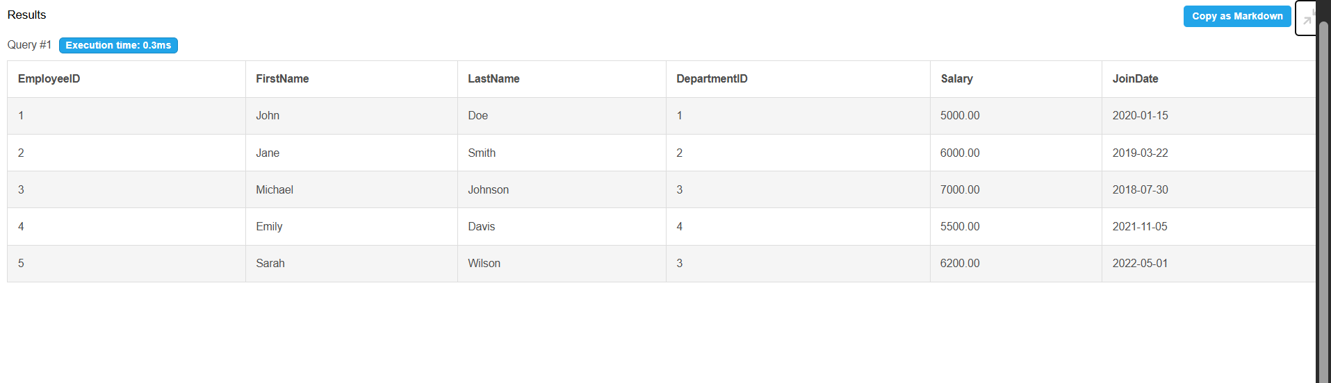

Task B: Get Employees by Department
(Simulating sp_GetEmployeesByDepartment)
Query to get employees in IT Department (DepartmentID = 3):
SELECT E.EmployeeID, E.FirstName, E.LastName, D.DepartmentName, E.Salary, E.JoinDate
FROM Employees E
JOIN Departments D ON E.DepartmentID = D.DepartmentID
WHERE E.DepartmentID = 3;
Output:
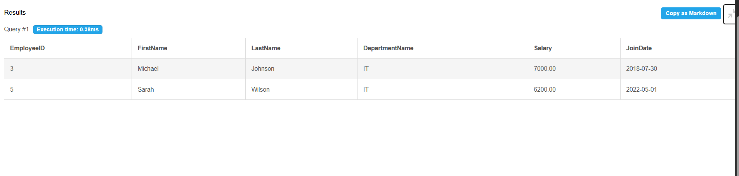

Final Output Check
SELECT * FROM Employees;
📤 Output:
Include the full table showing all 5 employees
